HELP MANUAL

GATE ENTRY WEB

Campus Together

DHIRUBHAI AMBANI INSTITUTE OF INFORMATION AND
COMMUNICATION TECHNOLOGY (DA-IICT)

GETTING STARTED

1.1 Web Gate Entry Manual

1.1.1 View My IN/OUT Gate Entry Log.
Supported User Classes: Student, Faculty

Step 1: Click on ‘Gate Entry’ tab on the navigation bar.

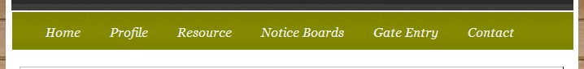
A form as shown below will be displayed on webpage.

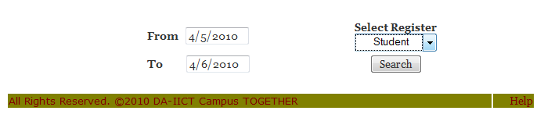

Step 2: Fill up the required fields appropriately and Click on ‘Search’ Button.

A Detailed table of the User IN/OUT entries at the Campus Gate would be displayed.

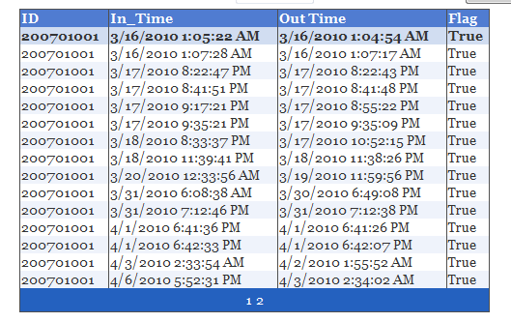

1.1.2 Register a Laptop
Supported User Classes: Hostel Supervisor

Step 1: Click on ‘Profile’ tab on the navigation bar.

The Following information would be displayed.

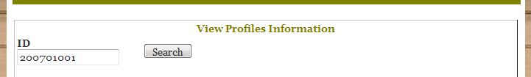

Step 2: Enter the Id of the person and Click on ‘Search’ Button.
The profile Information would be displayed.
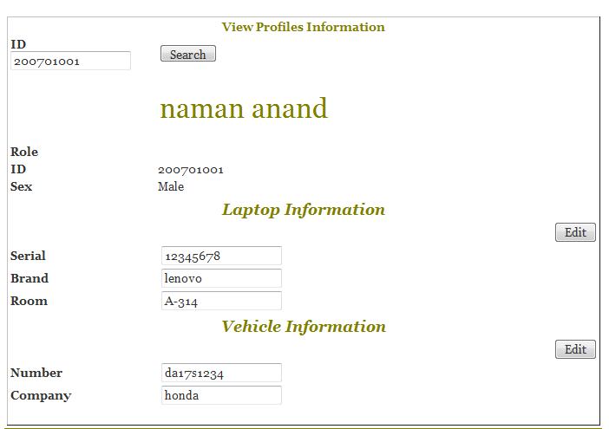

Step 3: Click on ‘Edit’ Button behind the ‘Laptop Information’ section.
The following Information would be displayed

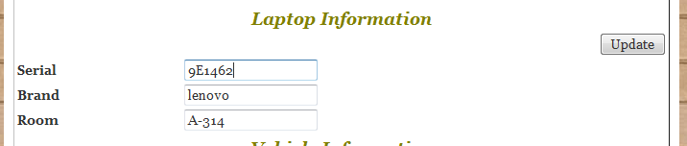

Step 4: Change/Update/Enter relevant Information in the Laptop information field and
Click on ‘Update’ Button behind the ‘Laptop Information’ section

The Laptop is registered.

1.1.3 Register a Student Vehicle
Supported User Classes: Hostel Supervisor

Step 1: Click on ‘Profile’ tab on the navigation bar.

The Following information would be displayed.

Step 2: Enter the Id of the person and Click on ‘Search’ Button.
The profile Information would be displayed.

Step 3: Click on ‘Edit’ Button behind the ‘Vehicle Information’ section.
The following Information would be displayed

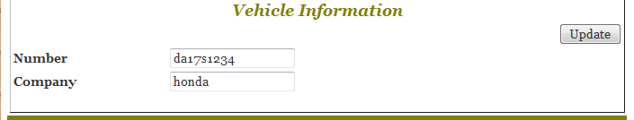

Step 4: Change/Update/Enter relevant Information in the Vehicle information field and
Click on ‘Update’ Button behind the ‘Vehicle Information’ section

The Vehicle is registered.

1.1.4 View a Users’ Gate Entry Log (Generate Reports)
Supported User Classes: Hostel Supervisor

Step 1: Click on ‘Gate Entry’ tab on the navigation bar.

The Following information would be displayed.

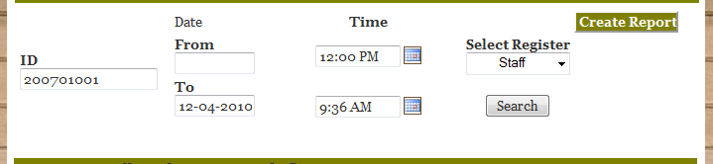

Step 2: Fill the ID of the person and other details as required in the field above.
Click on ‘Create Report’ Button behind the form.

The Following requested details would be generated on the page.
